%%%%%%%%%%%%%%%%%%%%%%%%%%%%%%%%%%%%%%%%%%%%%%%%%%%%%%%

**Example 4**

We carry out the simulation of aggregation-diffusion equation in a fan-shaped area with the initial data $ρ_{0} =e^{(−30(x^{2} + {(y+1)}^{2})) } + 0.01$. The internal energy density $H(ρ)$ and potential $W, V$ are described as follows:

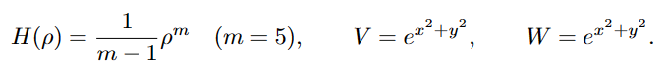

%%%%%%%%%%%%%%%%%%%%%%%%%%%%%%%%%%%%%%%%%%%%%%%%%%%%%%%

**Result**

1. **Free energy**

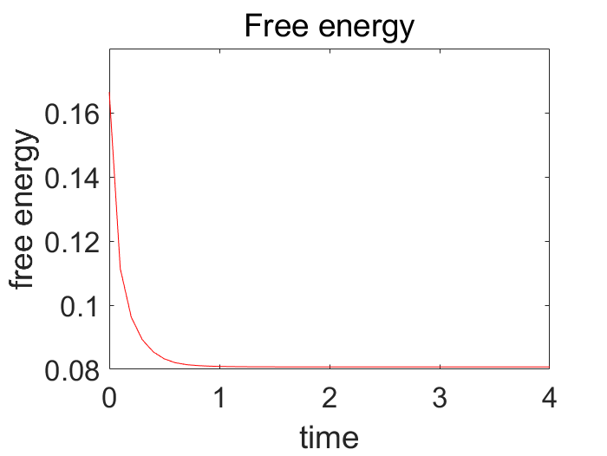

Figure 1 Mesh size(1/32), time step(tau=1/60000)

1. **The mass conservation**

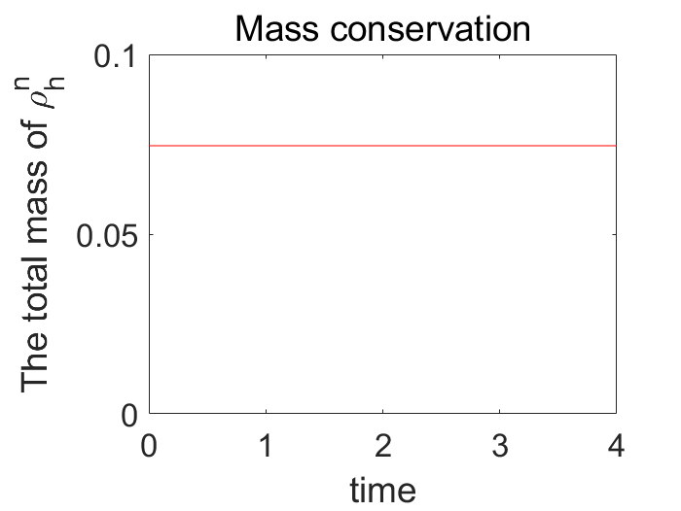

Figure 2 Mesh size(1/32), time step(1/60000)

1. **Numerical result**

|  |  |  |
| --- | --- | --- |
| rho_h_fill3_0  Figure 3 t = 0 | rho_h_fill3_1  Figure 4 t = 0.1 | rho_figure_at_t_0.2  Figure 5 t = 0.2 |
| rho_h_fill3_10  Figure 6 t = 1 | rho_h_fill3_20  Figure 7 t = 2 | rho_h_fill3_40  Figure 8 t = 4 |